For 1st and 2 nd question use this excel file : <https://drive.google.com/file/d/1dyDiqgNlQVS3Swtz8KjN1cb596801HVV/view?usp=sharing>

1. **Question:**

With the given automate the process of knowing profit of each app.

**Hint:** Use INDEX and MATCH Functions

**Answer:**

Firstly, create a drop-down list for select app. To create a drop down list follow the steps below.

1. Select the cell

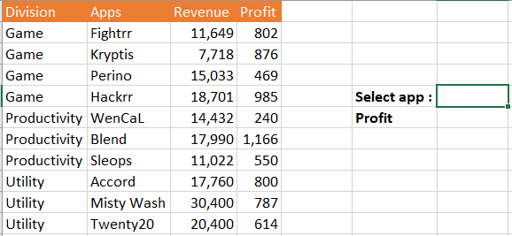

1. Data >> Data Validation >> Settings >> Allow >> List

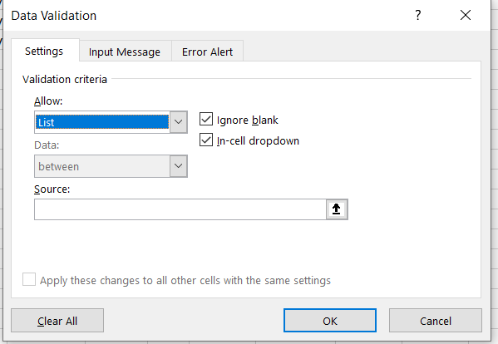

1. Source: select the input range

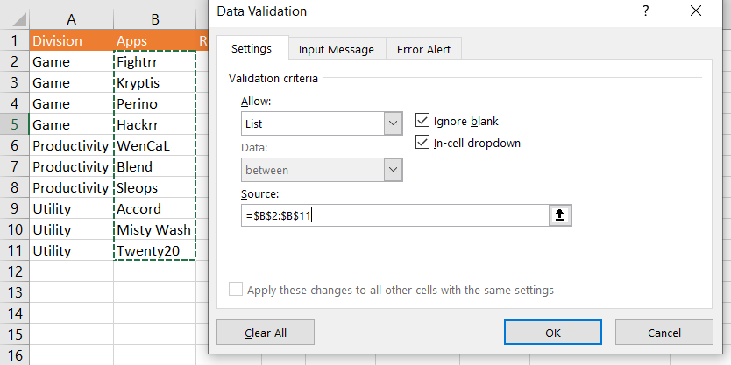

1. Now you can select the input

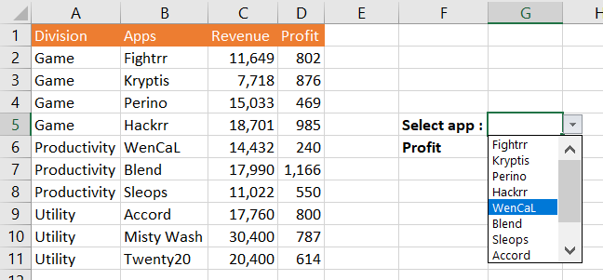

1. Select an app from the list and to know its profit

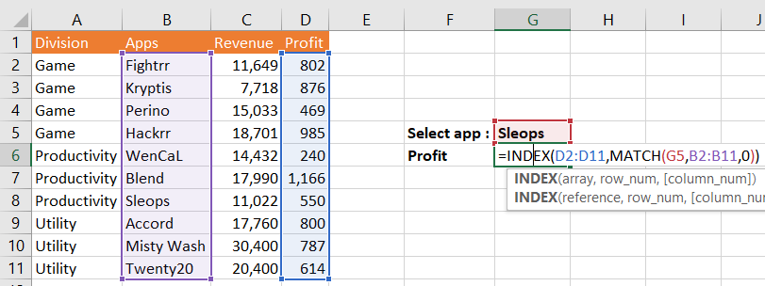

1. Now you can select any app to see it’s profit

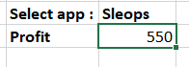  

1. **Question:**

How to know the profit and revenue both in a single drop down cell using 2 MATCH function inside an INDEX function.

1. Create a drop down for profit and revenue

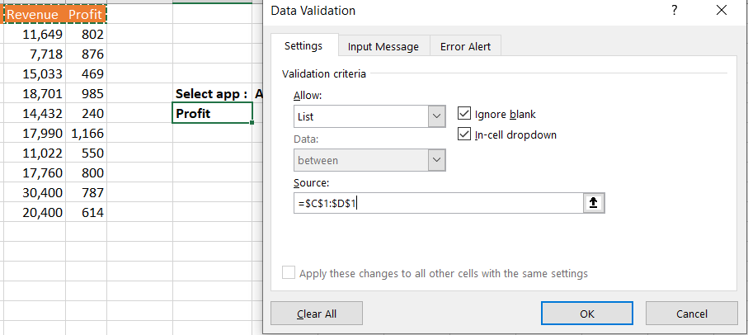

1. Now we can select revenue and profit for input to the MATCH and INDEX function

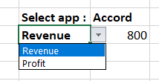

1. Now we can find the revenue and profit for any selected app

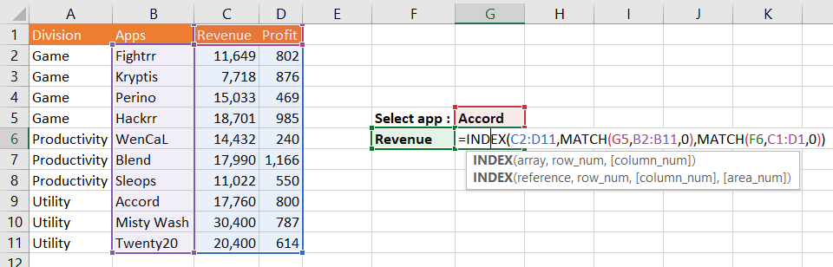

1. Now it’s automated to find the profit and revenue for any application

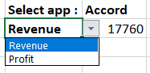 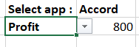 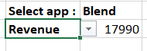

1. **Question:**

Download the data from <https://drive.google.com/file/d/1aTMZAc7aIwrr3y223uOfSdlAdgtHOhKT/view?usp=sharing>

From the given data create a billing system which will be like selecting flavour and size and it should return the price respected to them.

**Answer:**

* Create a drop down lost for flavor and size

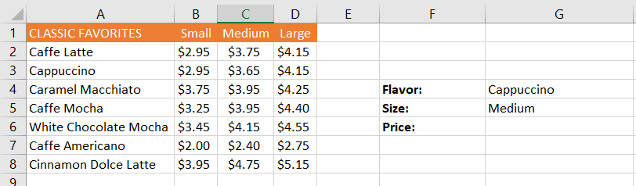

* **Find the respective price for selecting flavour and size**

